**The perspectives of opening a Russian restaurant in Scarborough, Toronto**

**Business Background and Problem**

Last year I was in Toronto and I was very surprised to see a lot of Russian speaking people. Later, a friend told me that after the fall of the USSR in Canada there was a huge wave of Russian emigrants from the former Soviet republics and now Toronto has an important Russian diaspora. These people remember their origins, they listen to Russian radio, look Russian TV and adore Russian food.

In consequence, I asked myself about the existence of Russian restaurants and if it’s possible to open a new one. In this case, in which part of Toronto it would have better chances to have more clients?

It’s a very interesting problem, as we should find an equilibrium in terms of location in order not to be close to other similar restaurants, being at the same time near the places where Russian diaspora lives and works. I’ll solve this problem, using this case also as a Capstone project for the current specialization

To achieve this goal, I will use the Data Science tools, learned during the courses of the IBM Data Specialization Program. Also I’ll use the Foursquare data, in order to find details about the characteristics of the analyzed places.

**Available data and how they will be used to solve the problem**

1. *Data on Toronto neighborhoods* – It’ll be used to model the city map, which will be the canvas for our model. Based on the city characteristics we’ll formulate our recommendations. I’ll take these data from the model elaborated in the last week’s lab.
2. *Population & Ethnic Distribution of Each Neighborhood – especially Russian people –* We’ll use these data in order to find the region with the highest proportion of Russian people. The data will be extracted using Toronto Census database - https://www.toronto.ca/city-government/data-research-maps/neighbourhoods-communities/ward-profiles/47-ward-model/
3. Number of Restaurants in Each Neighborhood (Foursquare API) – We’ll use the Foursquare API. This will help us to determine the “Restaurant Saturation” for each neighborhood, in order to avoid the opening of a new restaurant in an area “crowded” with this kind of institutions.
4. Number of Russian Restaurants in Each Neighborhood (Foursquare API) – The same source – Foursquare API. It’s a more detailed search of the point 3. We count the number of Russian restaurants in order to find low-density areas for this type of restaurants.

**The Used Methodology**

As we’ve focused on Scarborough, I’ve provided a clustering analysis using the data on Toronto’s neighborhoods and Machine Learning tools. I’ve combined the obtained map, with the Foursquare data on the most popular places for the obtained clusters, to choose the best place or region for the opening of a Russian restaurant.

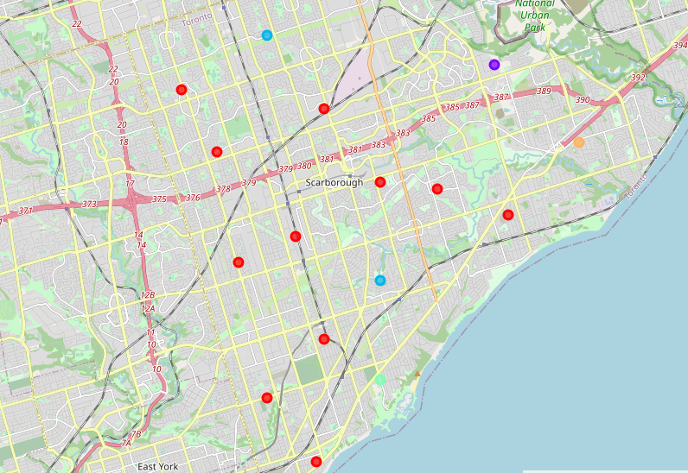

You can see above the obtained clusters for Scarborough. I had to restrain the analysis of this neighborhood, given the continuity of the past project.

As a starting point for my analysis, I decided to focus on the first and the biggest cluster, represented with red dots. It covers 6 wards: Agincourt, Center, Guildwood, North, Rouge Park, and South-West.

After a socio-demographic analysis of these neighborhoods, I selected the ward 20 – Scarborough Southwest which has the following characteristics:



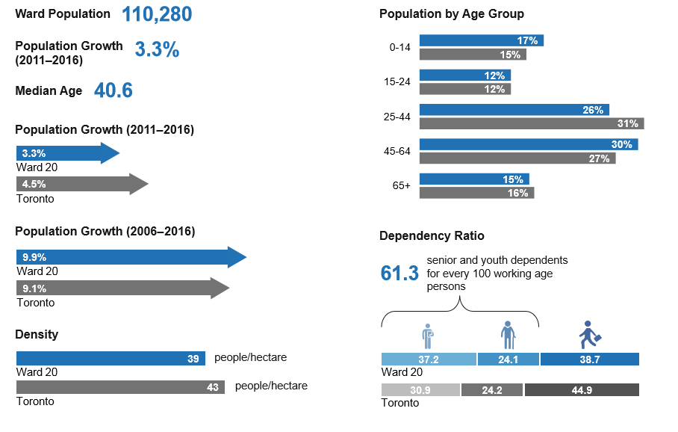

So we see that the size and the density of the chosen region are pretty acceptable. Moreover, our goal is to open a Russian restaurant, so we should look for some cultural affiliation. The other wards have an Asian population, which is far from our “European” positioning. In our case, the ethnocultural profile is the following:

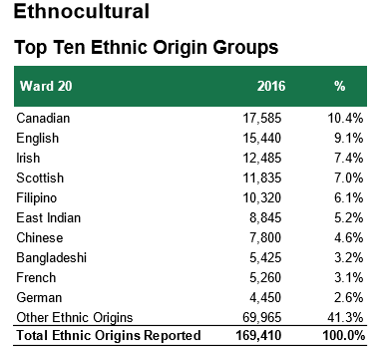

The Canadian and English origins will make the advertising campaign easier and cheaper, given a stronger cultural affinity.

**Results**

The study of the Scarborough borrow showed the absence of any important Russian community. The population of the analyzed wards has a preponderant Asian origin, except the Ward 20 - Scarborough Southwest, which has a more “European profile”. Our clustering analysis showed this ward as a part of the first, and the biggest cluster, which has the highest economic activity

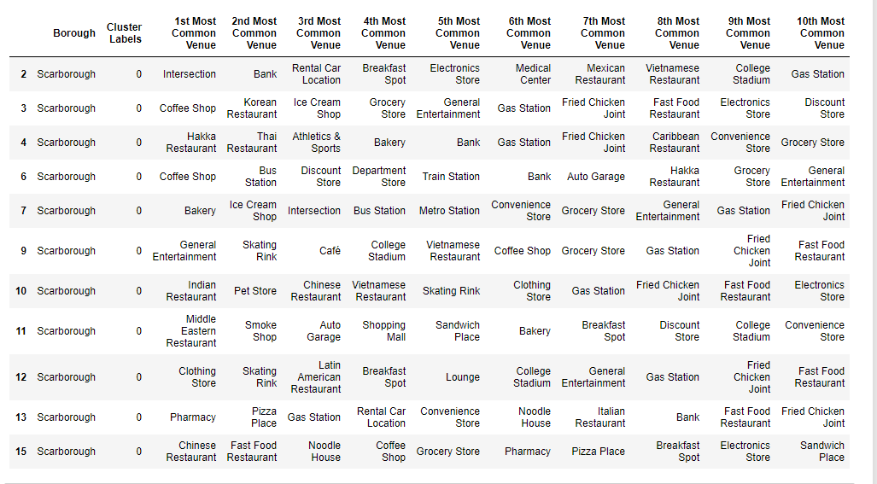

These are the main reasons for which we selected this ward as a place to open our business: a Russian restaurant. We see that it has fairly good chances to succeed, given the high popularity of the restaurants among the population of the selected cluster.

**Discussions**

The main finding of this study is the absence of an important Russian minority, which can represent a big problem for the incipient phase of our business. However, we consider that we’ve extracted the maximum from the analyzed borough. An eventual next step will be an inclusive ML clustering of the entire Toronto area, to find the places with a higher concentration of Russian people and the highest commercial potential.

**Conclusions**

During this Capstone project, I’ve analyzed the Scarborough borough in Toronto, to find the best place for the launch of a Russian restaurant.

We used a Machine Learning algorithm, to make a cluster analysis of the mentioned borough. After, we compared the obtained clusters with the ethnic profile of each ward from the chosen cluster. We selected the Ward 20 - Scarborough Southwest, as its population has European origins, which will make it easier to advertise our business.

The further development of this analysis will be the study of the entire area of Toronto, to find the places with the highest concentration of Russian and Slavic population and good commercial potential. In these places, we’ll eventually open another restaurant.